### **Guide to Recycling by Material**

Recycling is a crucial step toward protecting our environment by reducing waste and conserving natural resources. However, not everything can be tossed into the recycling bin! Understanding how to properly recycle different materials ensures that your efforts are effective. This guide provides clear answers to common questions about recycling various items and materials like paper, plastic, glass, metals, and more.

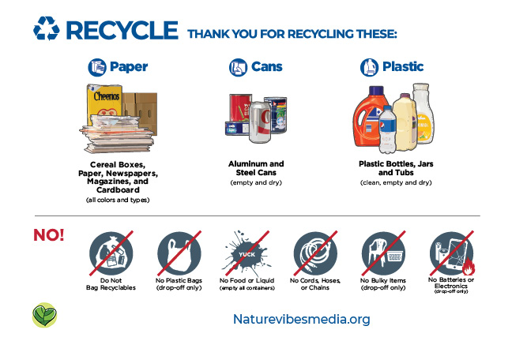

### **Paper & Cardboard**

Paper makes up 23% of the municipal solid waste in the U.S., and recycling it is one of the simplest ways to cut waste and conserve natural resources. In 2018, Americans recycled about 68% of the paper they used. Here's how you can contribute:

**FAQs:**

* **Can I recycle newspapers?** Yes, newspapers can be recycled.
* **Can I recycle magazines?** Yes, magazines are recyclable.
* **Can I recycle pizza boxes?** Yes! Even if they have grease, just remove any food scraps and flatten the box.
* **Can I recycle mail?** Yes, even envelopes with plastic windows can go in the recycling bin.
* **Are paper and cardboard takeout containers recyclable?** It depends. Containers need to be "spatula-clean"—free from significant food residue.
* **Can cardboard boxes be recycled?** Yes, just flatten them. Examples include egg cartons, cereal boxes, and shoe boxes.
* **Can shredded paper be recycled?** Check your local recycling program, as rules vary.
* **Can books be recycled?** Yes, paperback books can be recycled as-is. For hardcovers, remove the cover first.
* **Can gift wrap be recycled?** Only if it's plain paper without a shiny coating. Consider reusing gift wrap or using newspaper instead.

**Pro Tip**: Look for paper products made from recycled materials and reduce paper use by printing less.

### **Plastics**

In 2018, the U.S. generated over 35 million tons of plastic waste, but only 8.7% was recycled. Since plastic recycling varies by location, it’s important to know what your local program accepts.

**FAQs:**

* **Can I recycle plastic bags, wraps, and films?** Yes, but not curbside. Many grocery and retail stores accept these items for recycling.
* **Can plastic bottles and caps be recycled?** Yes, and you can usually leave the caps on!
* **Can styrofoam be recycled?** Rarely. Check Earth911 to find drop-off locations.
* **Can plastic containers, cups, and utensils be recycled?** It depends on the type of plastic and your local program. Generally, food-contaminated items should not be recycled.
* **Can I recycle compostable or bio-based plastics?** No, compostable plastics can contaminate recycling streams. Check if your community has composting programs for these items.

**Pro Tip**: Always rinse plastic containers before recycling to avoid contamination.

### **Glass**

Glass is one of the easiest materials to recycle, as it can be recycled repeatedly without losing quality. In 2018, 31.3% of glass was recycled in the U.S.

**FAQs:**

* **Can I recycle different glass colors/types together?** Yes, most programs accept mixed glass.
* **Can I recycle broken glass?** No, broken glass can harm workers and damage machinery.
* **Can I leave metal caps on glass bottles?** No, metal bottle caps should be recycled separately.

### **Aluminum**

Aluminum is highly valuable in the recycling world because it can be reused indefinitely. In 2018, about 34.9% of aluminum waste was recycled.

**FAQs:**

* **Should aluminum cans be crushed?** It depends. In single-stream recycling, cans should remain uncrushed for sorting machines, but in multi-stream systems, crushing is fine.
* **Can aluminum foil be recycled?** Yes, as long as it's clean.

### **Batteries**

Batteries contain hazardous materials and should never be thrown into regular trash or recycling bins. In 2018, 99% of lead-acid batteries were recycled, but other types lag behind.

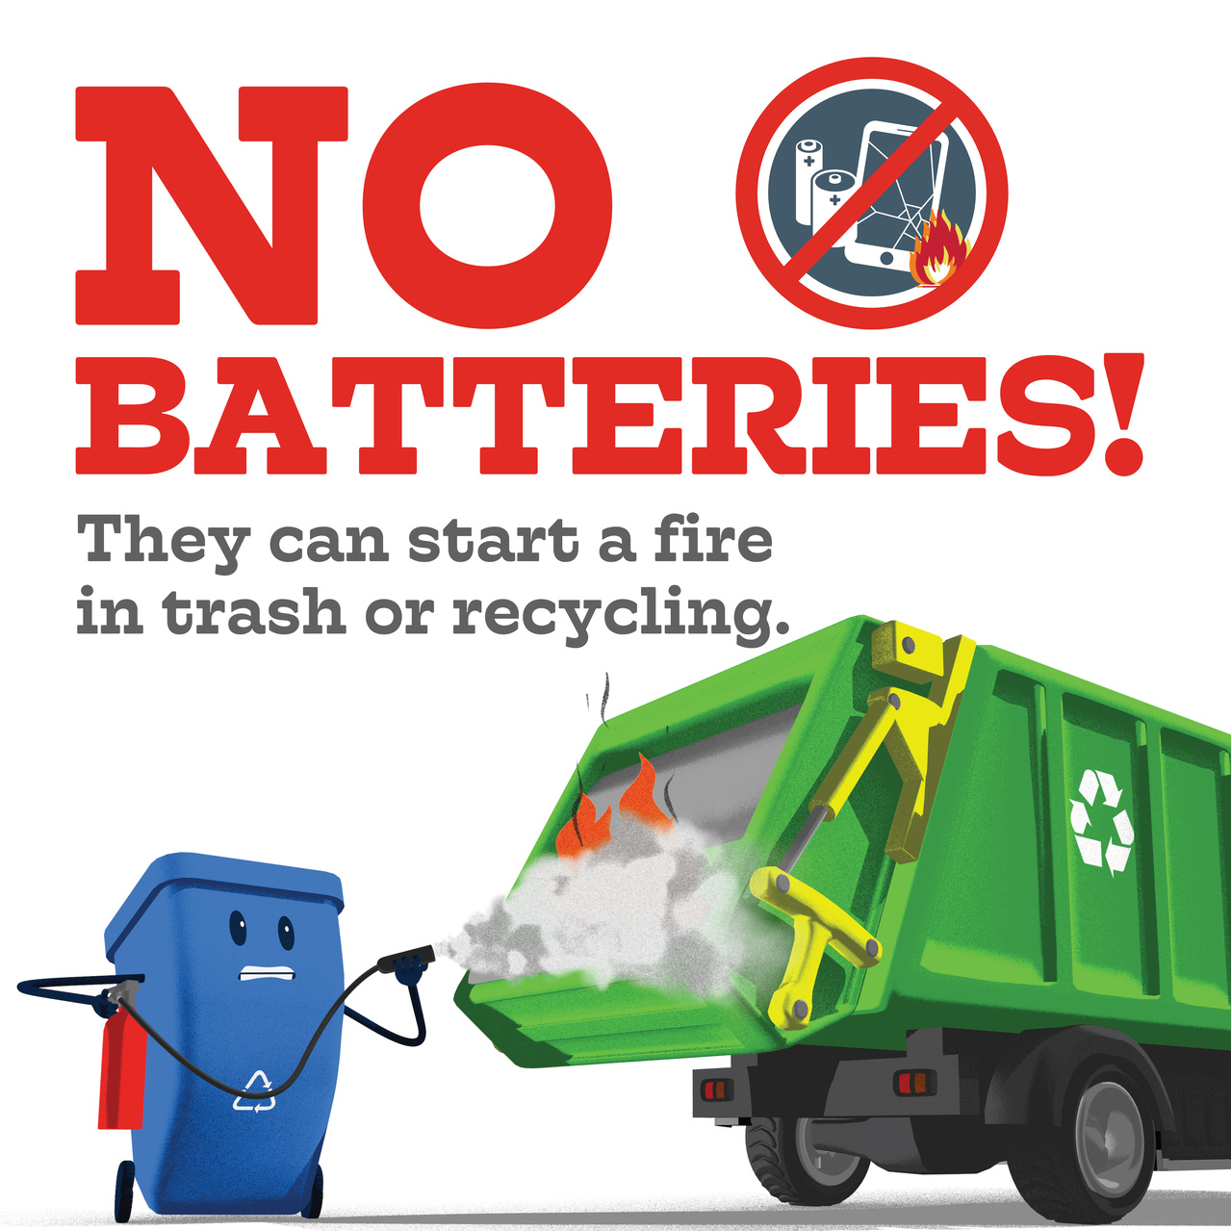

**FAQs:**

* **What should I do with household batteries?** Many stores and community centers accept batteries for recycling.
* **What should I do with lithium-ion batteries?** These should be dropped off at designated locations, not placed in your curbside bin.
* **What about car batteries?** Return them to retailers or take them to special hazardous waste collection centers.

### **Electronics**

Electronic waste, or e-waste, includes items like cell phones, computers, and televisions. In 2018, about 38.5% of e-waste was recycled.

**FAQs:**

* **Can I recycle electronics curbside?** No, electronics need to be taken to specific collection points or retailers for recycling.
* **What should I do before recycling electronics?** Always delete personal data before recycling any device.

### **Food**

While food cannot be recycled, it should not be sent to landfills. Instead, composting is the best way to manage food waste, which contributes to greenhouse gas emissions when it rots in landfills.

**FAQs:**

* **What’s the best way to dispose of food waste?** Composting! If you can’t compost at home, check if your community offers a collection service.

### **Lawn Materials & Used Oil**

Lawn trimmings and motor oil are valuable resources when recycled properly.

**FAQs:**

* **Can I recycle lawn materials?** Lawn materials like grass clippings can be composted.
* **Can I recycle used oil?** Yes, many auto-supply stores accept used motor oil for recycling.

### **Household Hazardous Waste**

Household hazardous waste includes items that can catch fire, explode, or are corrosive, such as pesticides, paints, and certain chemicals.

**FAQs:**

* **How do I dispose of hazardous waste?** Take these items to local collection events or hazardous waste centers. Never pour them down the drain!

### **Metal**

Metal items like iron, steel, and non-ferrous metals (e.g., copper, aluminum) are widely recyclable.

**FAQs:**

* **Can I recycle metal curbside?** Check with your local program, as this depends on your area.

### **Tires**

Old tires can harbor disease-carrying pests and pose fire hazards if abandoned. Most tire retailers will accept used tires for recycling when you buy new ones.

### **Miscellaneous Items**

Certain items, like dirty diapers or old clothing, require special care when disposing of them.

**FAQs:**

* **What should I do with dirty diapers?** Dispose of them in the trash after flushing any waste.
* **What should I do with old clothes and shoes?** Donate gently used items to charities or look for stores that accept clothing for recycling.

### **Additional Info**

### **Links To External Resources** [**California Recycling Guide**](https://athensservices.com/recycling-guide/)

[**City Specifc Recycling Guide**](https://athensservices.com/recycling-guide/) - Municipal City-Specific Pages. Residential, commercial businesses and industrial customers may find local service information, holiday schedules, bill pay, and other details specific to your municipality, by choosing your website below.

For more in-depth information on recycling rules and programs in your area, visit the [EPA’s Recycling Guide](https://www.epa.gov/recycle/frequent-questions-recycling#recycling101) or consult local waste management services like [Waste Management](https://www.wm.com/us/en/recycle-right/recycling-101#rules).  
  
**https://how2recycle.info/about-the-how2recycle-label/check-locally/**